Removed text that can be put into appendices

BE is American beech (Fagus grandifolia), MW is musclewood (*Carpinus caroliniana)*, SH is shadbush (*Amelanchier canadensis*), SM is striped maple (*Acer pennsylvanicum*), SB is sweet birch (*Betula lenta*), WH is witch-hazel (*Hamamelis virginiana*), AO is autumn olive (*Eleagnus umbellata*), BA is Japanese barberry (*Berberis thunbergii*), BU is burning bush (*Eunonymous alatus*) and HS is Morrow’s honeysuckle (*Lonicera morowii*).

Fig. 3. Effects of bird-bag exclusion treatment under the context of native versus non-native host-plant groups. Points with lines connecting them are significantly different from each other if they have different letters (Scheffe’s test for pairwise comparisons were completed for each of the eight sub-panels). Each panel indicates the response of a single taxonomic group and changes in Mean ± SEM abundance: 3a. Araneae (true spiders), 3b. Hemiptera (herbivorous true bug families), 3c. Lepidoptera (caterpillars), and 3d. Orthoptera (tree crickets and katydids).

Fig 3a, 3b, 3c, 3d.

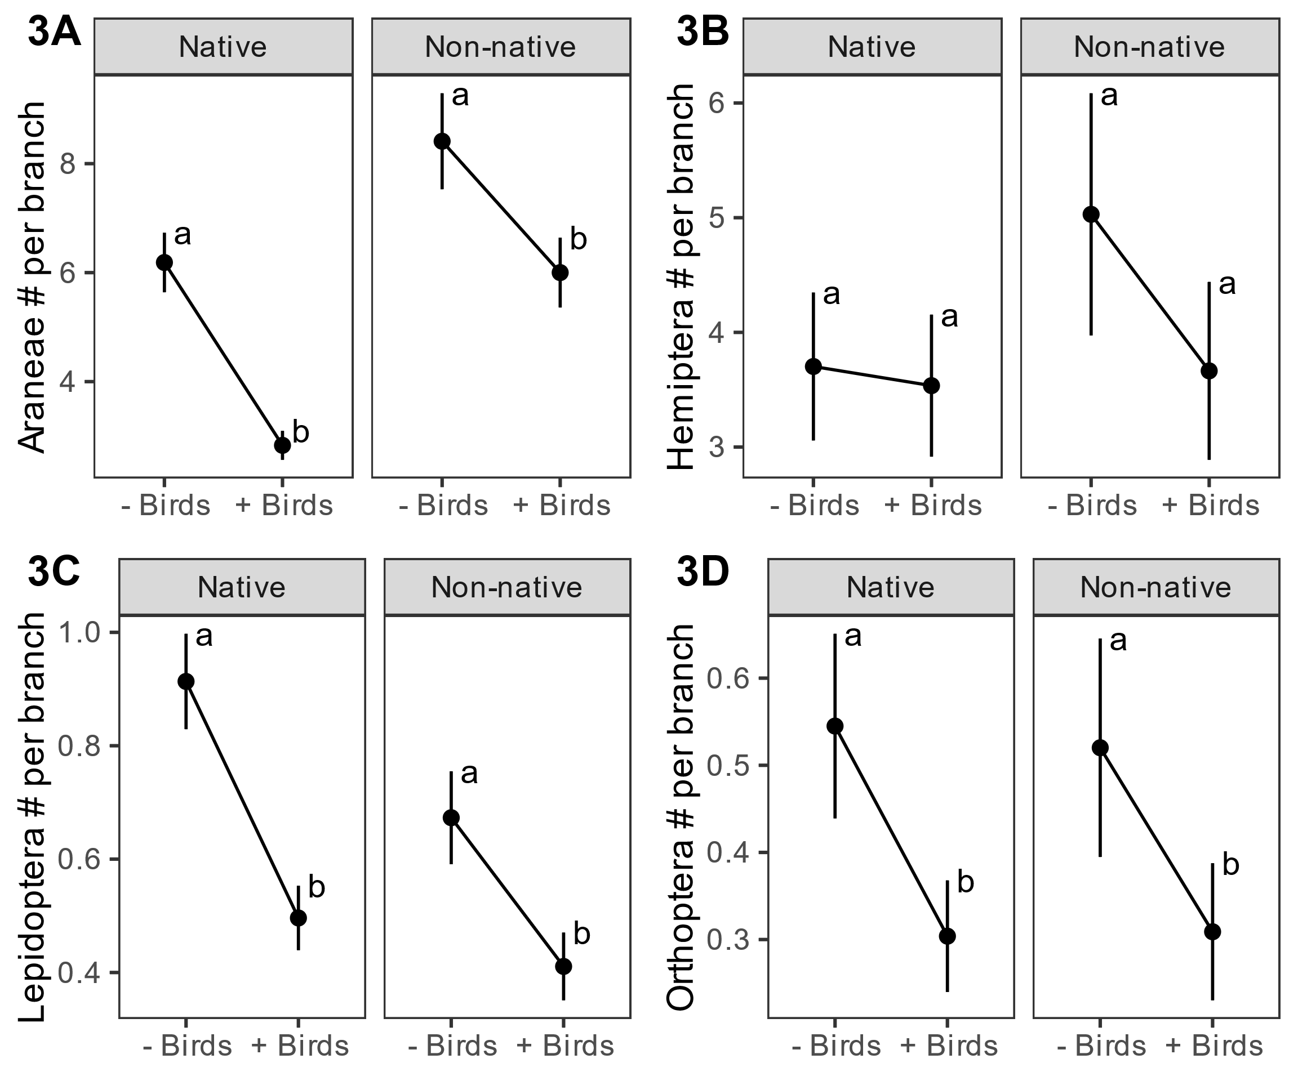

Fig 4a, 4b.

